Year 9 Biomes and Food Security – Source Page

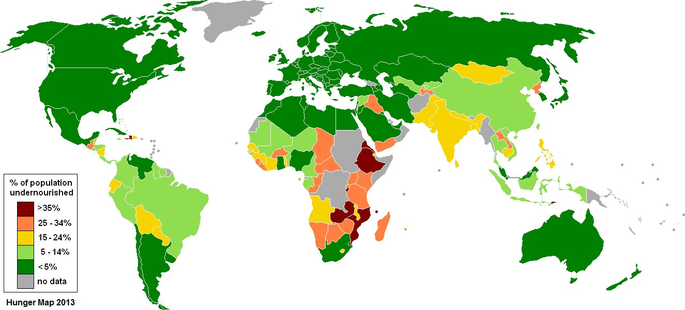

Source 1 - United Nations World Food Program’s Hunger Map – Wikipedia Commons. (2013).

Source 2 – Whittaker Biome Diagram – Communities and Ecosystems (1975)

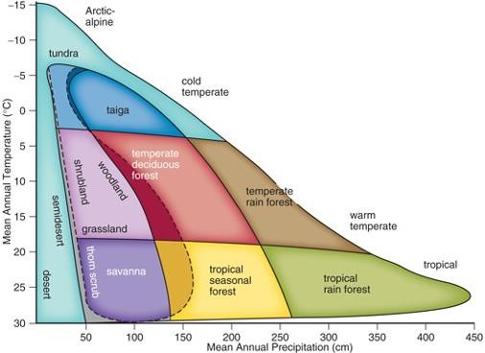

Source 3 – Land Used for Agriculture Map – Scientific American. (2015).

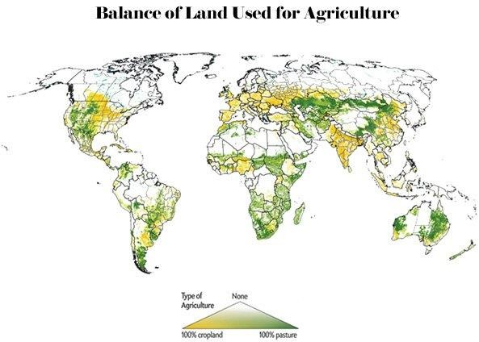

Source 4 – World’s Major Biomes Distribution – Boundless Biomes (2013)

